**Ibalio RE 570 Investment Memo**

Date: 10/21/2024

To: Professor Steve Bell

From: Matthew Ibalio ARGUS Analyst

Re: Oak Brook Tower Investment Analysis

EXECUTIVE SUMMARY

An analysis has been conducted to develop recommendations as to the offering and taking price for Oak Brook Tower as a core investment asset. The analysis was conducted by first collecting competitive data from CoStar, demographic data from STDB, and then analyzing Oak Brook Tower’s current data using ARGUS. The data was then utilized to conduct an analysis of the property using a 7% discount rate suing best-case, worst-case, and most-likely-case scenarios.

The analysis was conducted assuming no loans, a 10-year holding period, a 7.5% terminal cap rate and a base discount rate of 7%. After analyzing demographic, market, and financial data for Oak Brook Tower, it is recommended that with a 7% discount rate and 7.5% terminal cap rate, the property be purchased at $31,553,681 [$315.54/SF] with a most probable sale price of $32,122,603 [$321.23/SF]. The wort case sale price would be $22,056,031 [$220.56/SF]and best-case sale price would be $47,114,023 [$471.14/SF]

Oak Brook Tower has demonstrated a consistent track record of attracting high credit tenants willing to pay excellent rental rates. A stable 5-mile population of upper middle-class earners, growing average household income, and desirable location support classifying the property as a “core” asset with enough demand to support the $32,122,603 sale price in 10 years.

PROPERTY ANALYSIS

**Property Summary**

Oak Brook Tower was built in 1990 and has a total of 100,000 rentable square feet across seven floors, including a Chipotle restaurant on 5,000 rentable square feet on the first floor. The upper floors are for office tenants which three in place tenants.

The property is a 10-unit, 3 story mixed use building (office/retail) located on 1400 West 16th Street in Oak Brook, IL 60523. There are 7 floors, the first being 5,000 rsf and is currently occupied by Chipotle. The upper floors are for office tenants. Currently there are 3 office tenants: First Title, Design Partners, and Citibank. There is a static vacancy of 2,000 SF and 4 vacant leases created quarterly over a 1-year period. The 4 vacant leases make up 27,000 SF.

**Location Analysis**

Oak Brook Tower is located on 1400 West 16th Street in Oak Brook, IL. The property is over thirty years old and well maintained. It sits in a desirable location, providing excellent access to I-88, Tri-State I-294 Tollway, I-290, I-55, Route 83 and Butterfield Road for traffic coming in and out of the area. Tenant employees and clients would have no issues going to and coming from the property.

Within a 5-mile radius sits high traffic areas including Oak Brook Center, Yorktown Center, and Lifetime Fitness. In addition, there are more than 12 restaurants, four hotels and six financial institutions within a one-mile radius of Oak Brook Tower, adding benefits to tenants located within the property and. These benefits serve to attract top talent and clients for prospective tenants.

The desirable location also serves to maintain the property’s history as a first-class office building that lease to high credit tenants.

**Demographics Analysis**

Demographic information for the surrounding area was analyzed in radii of 1, 3, and 5 miles from the property. The current overall demographics for the surrounding area indicate a population that will remain flat with a growing average household income and household size.

This means there’s a stable pool of upper middle-class[1] employees to hire from for Oak Brook Tower tenants. This is an educated pool with 50%+ of the population over 25 having earned a bachelor’s degree and/or a Graduate/Professional Degree.



**Current Tenants Analysis**

There are two types of tenants at Oak Brook Tower, retail and office.

**Retail Tenants**

The only retail tenant is Chipotle, and they rent 5,000 square feet with a lease expiration date of 8/25 with a 5-year option. Recoveries are a fixed pro-rate share of 6% of Net operating expenses, natural pro-rata share of Net real estate taxes, and total retail expenses.

**Office Tenants**

Citibank is the largest office tenant with 36,000 square feet and a 5-year option. The second largest is Design Partners with 20,000 square feet and then First Title with 10,000 square feet.

Recoveries for First Title, Design Partners, Citibank, and the future tenants are operating expenses and real estate taxes with a base year stop. Utilities are paid by retail.

There is also 2,000 square feet of un-leasable space.

**Market Potential and Competitive Set of Properties**

When examining the market for Oak Brook Tower, the primary focused was placed upon similar class A office buildings and buildings for retail use.

**Competitive Office Buildings**



For competitive office buildings the rent per square foot varies with the high end being $31 for a building built in the 1980’s and the low end being $15 for a building built in the 1990’s but 100% vacant. Oak Brook Tower being one of the newer properties and located off a major highway supports the higher end $30 market rent forecasted. The demographic forecast discussed earlier also supports that there is likely not to be a significant shift in traffic from Oak Brook IL to outside of the 5-mile radius.

**Competitive Retail Buildings**



There was only one office building with retail space within a 5-mile radius. To expand on the competitive set for retail space, the CoStar data included retail buildings. The mixed-use space for Oak Brook Tower makes it unique within the competitive set. Given high credit tenants have historically leased space within the building and the population can be expected to have high-end middle-class wages to spend, the retail lease is a prime space for prospective tenants supporting the excellent rent of $60.

**Site/Building Analysis including deferred maintenance where applicable**

A site/building analysis was not required for this investment memo.

FINANCIAL ANALYSIS

**Assumptions**

It is assumed that the holding period for the investment would be for 10 years. Expenses and the market rate will both increase by the same 3% annually. A vacancy rate of 3% of total tenant revenue will be used.

Monthly rents in the best-case and worst-case scenarios represent a 10% increase and 20% decrease (respectively) versus the expected probable case rents. Additionally, the scenarios reflect that both vacancy rates and expenses are not expected to increase more than 3%.

**Proposed Financing**

No debt financing will be used to purchase Oak Brook Tower, only simple equity.



**Best Case Analysis**

In a best-case scenario, office rents may achieve a $34.00/sf and retail rents can reach $67.00/sf in year one. Office rents would still be expected to grow by 6% in 2022, 5% in 2023, 4% in 2024 and 3% thereafter. Retail rents are also expected to maintain it’s growth forecast of 3% after 2021.

**Worst Case Analysis**

In a worst-case scenario, office rents can drop to $23.00/sf and retail rents can drop to $47.00 in year one. The growth rates are expected to remain the same.

**Probable Case Analysis**

In the most probable-case scenario for year one, office rents are the same as expected at $30.00/sf and $60.00/sf for retail.

**Partitioned IRR**

The partitioned IRR is used to quantify how much of the total potential return comes from regular operations of the property versus the sale price.

With a forecasted total NOI of $27,626,616 and forecasted sale price of $32,122,603, the total percentage of cash flow available for distribution from operating income is 43.08% and 56.92% from the sale of the property.

At a 7% discount rate most of the total potential return is coming from the sale of the property. Generally, a greater percentage of distribution attributable to the assumed sale price equates to a greater risk of not achieving the projected returns due to the unpredictability of future sale prices. In the case of Oak Brook Tower, the distribution difference is small. A small distribution coupled with the prime location and prestigious history of hosting high credit clients means the targeted investment returns are unlikely to deviate in 10-years.

RECOMMENDATIONS  
Based on the market data available on CoStar, the demographic data from STDB and the analysis conducted using ARGUS, the recommendations for taking and asking prices are as follows:



It is recommended that a “fair” purchase price for Oak Brook Tower would be $31,553,681 and a sale price of $32,122,603. The demographics are forecasted to maintain it’s high earning middle class population providing a strong pool of employees for tenants. The surrounding landmarks also benefit from the high earning and stable population by maintaining the prestigious status the Oak Brook area. Oak Brook Tower is also newer than most of its competition and the location supports the higher market rent expected ($30). Given it has been well maintained over the years, it’s not expected to require excessive repairs and maintenance over the 10-year holding period. The property can provide a stable source of returns as a “core” investment, providing 43% of the forecasted returns from net operating income and 57% net proceeds from the sale. The smaller spread allows for a more reliable expected return.

EXHIBITS

STDB Community Profile Report

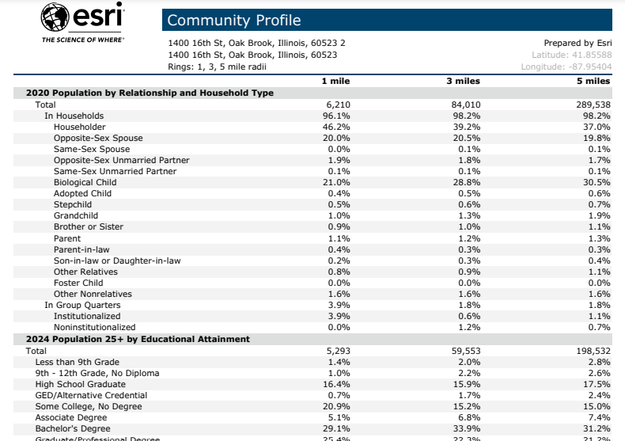

STDB 1-3-5 Mile Summary Dashboard

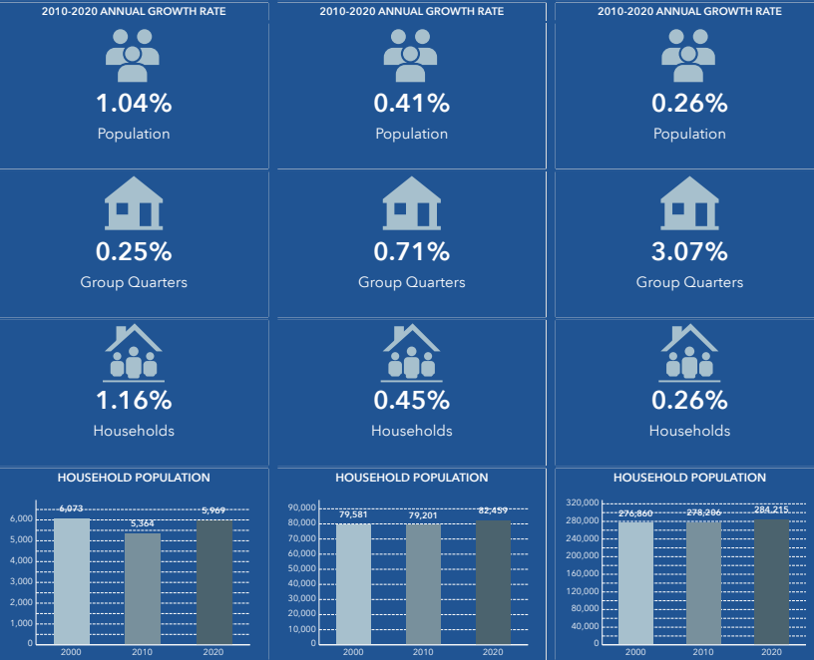

CoStar 1



ARGUS Cash Flow Summary Report

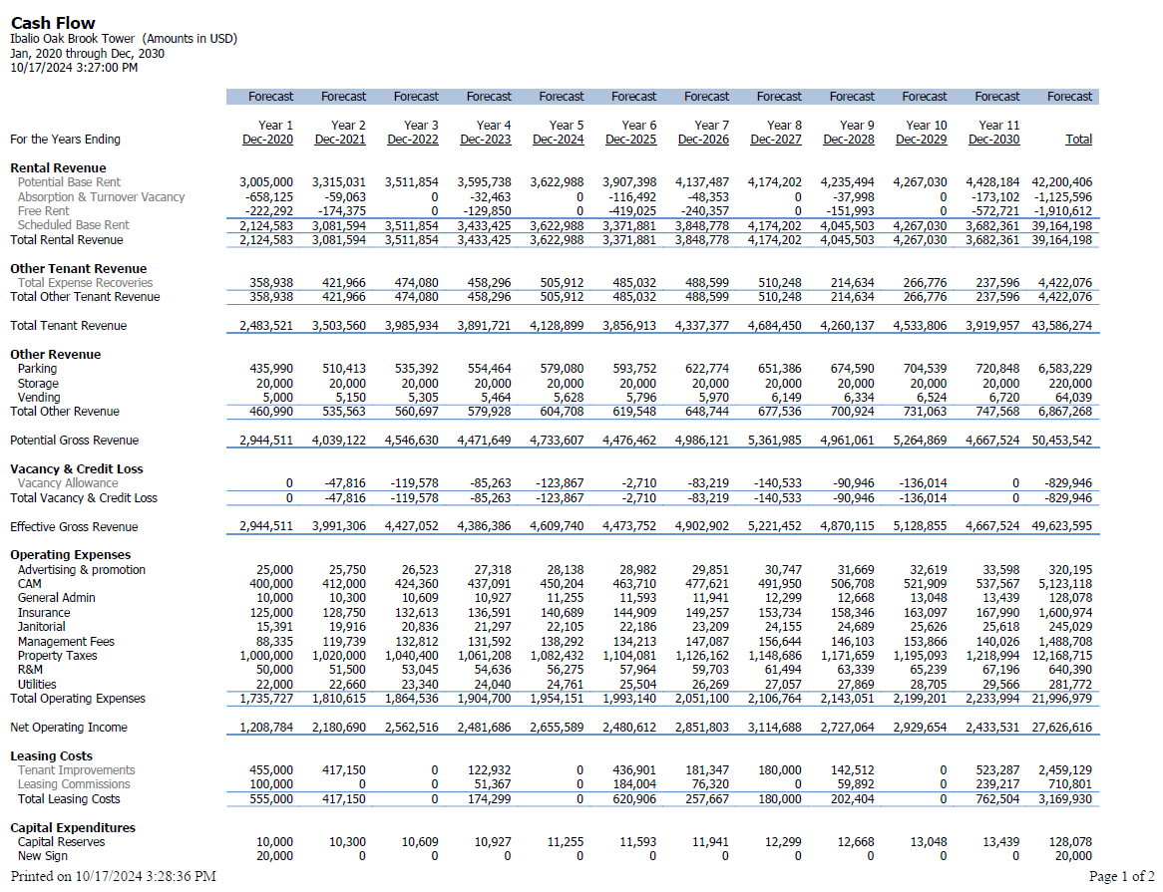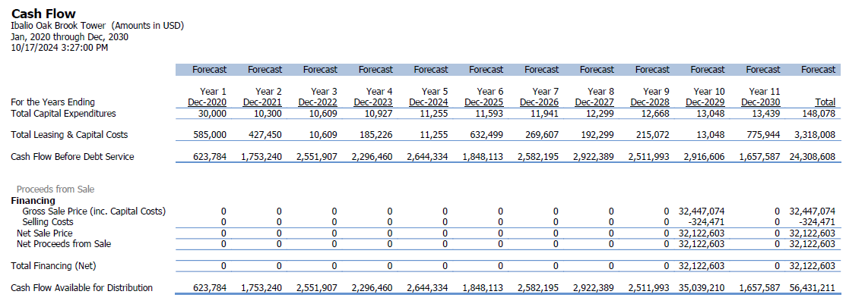

ARGUS Property Summary Report

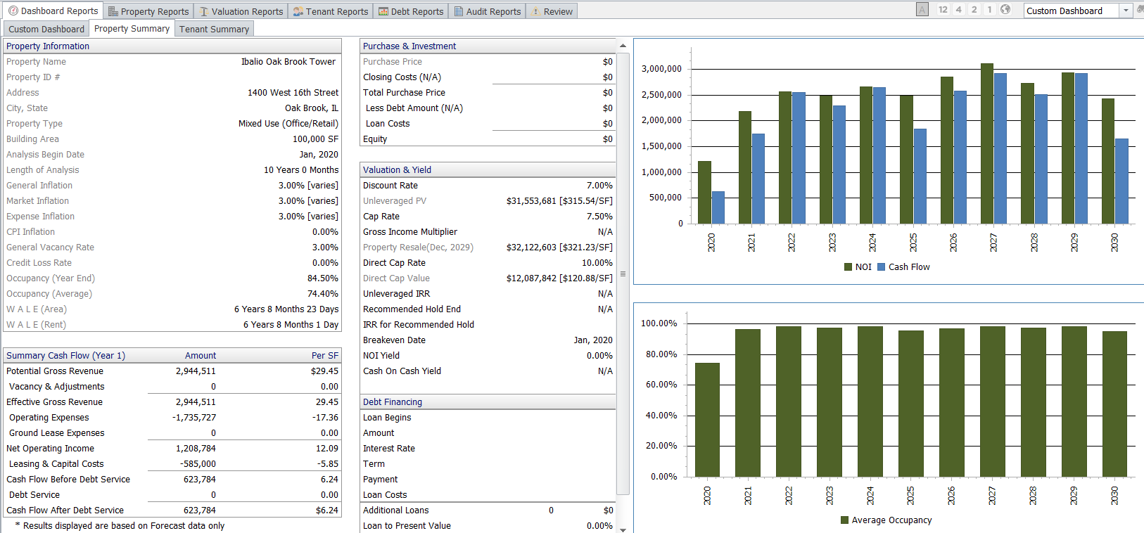

1. *Yahoo is part of the Yahoo family of brands*. (n.d.). https://finance.yahoo.com/news/much-earn-middle-class-illinois-110000823.html